Literacy support worksheet

7.1 Displacement is change in position with direction

Pages 156–157

Distance and displacement

1 Complete the following table by writing the correct definitions in the spaces provided. Complete the second column of the table below with your definitions, showing your understanding of the key terms to the left. Once you have finished, discuss with someone else in your class, and write down their understanding of the key terms in the third column.

|  |  |  |  |
| --- | --- | --- | --- |
| **Key term** | **My understanding of  this term** | **My classmate’s understanding of this term** | **Actual definition** |
| Distance |  |  | How far an object travels over a certain period of time. |
| Displacement |  | . | A vector quantity that measures the change in position of an object and its direction over a certain period of time. |
| Scalar quantity |  |  | A quantity that only has size (or magnitude) and no direction (e.g. distance). |
| Vector quantity |  |  | A quantity that has size and direction (e.g. velocity, displacement). |

2 Name two reasons why displacement is a vector quantity.

|  |
| --- |
|  |
|  |

3 Name two ways to represent the movement of an object.

|  |
| --- |
|  |
|  |

4 A girl rides a skateboard. Her journey is shown on the graph below.

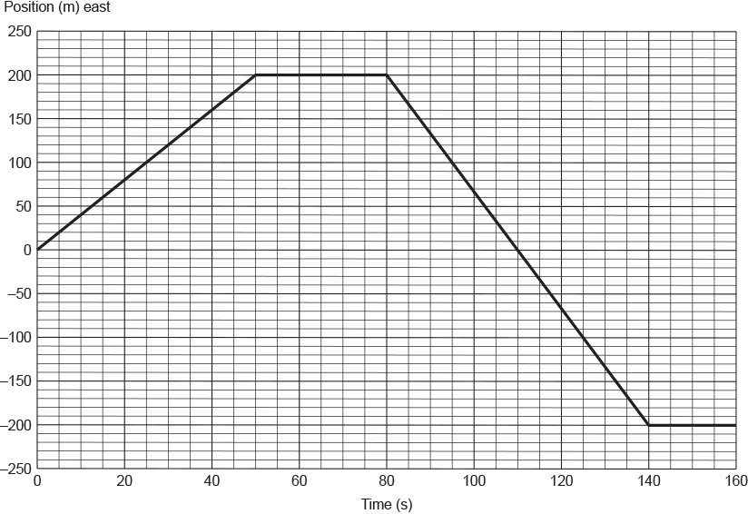

a How far did the girl travel in 160 seconds?

|  |
| --- |
|  |

b What was the girl’s displacement at each of the following times? The first one has been done for you.

i *t* = 50 s

200 m

ii *t* = 110 s

|  |
| --- |
|  |

iii *t* = 110 s

|  |
| --- |
|  |

Word detective – Fill in the blanks

5 Use the following word list to fill in the blanks in the sentences below to describe the girl’s motion as shown on the graph in question 4.

Word list: 400 m, constant, starting, opposite, doesn’t move

For example: From *t* = 0 s to *t* = 50 s, the girl travelled a distance of 200 m.

a From *t* = 50 s to *t* = 80 s the girl \_\_\_\_\_\_\_\_\_\_\_\_\_\_\_\_\_\_\_\_\_\_\_\_\_\_\_\_\_\_\_\_\_\_\_.

b From *t* = 80 s to *t* = 140 s the girl travelled at a \_\_\_\_\_\_\_\_\_\_\_\_\_\_\_\_\_\_\_\_\_\_\_ speed but in the \_\_\_\_\_\_\_\_\_\_\_\_\_\_\_\_\_\_\_\_\_\_\_\_\_ direction to her original motion.

c At *t* = 110 s she passed her \_\_\_\_\_\_\_\_\_\_\_\_\_\_\_\_\_\_\_\_\_\_\_\_\_\_\_\_\_ point.

d She travelled a total distance of \_\_\_\_\_\_\_\_\_\_\_\_\_\_\_\_\_\_\_\_\_\_\_\_\_\_ during this time interval.

Literacy support worksheet

7.2 Velocity is speed with direction

Pages 158–159

Speed and velocity

1 Explain the difference between speed and velocity by completing the table below.

|  |  |
| --- | --- |
| **Speed** | **Velocity** |
|  |  |

2 Look at the two equation triangles. Label which triangle can be used to calculate speed and which triangle can be used to calculate velocity.

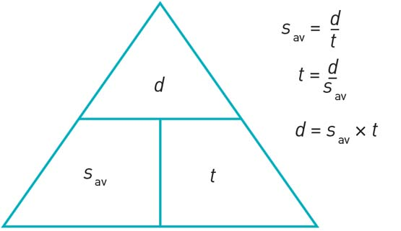

|  |
| --- |
|  |

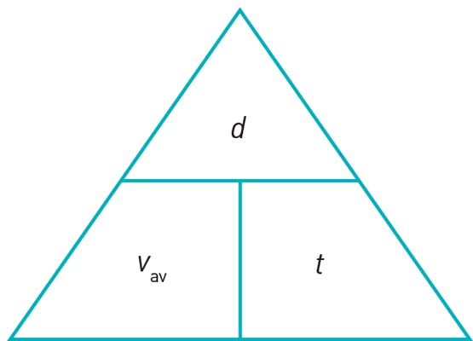

|  |
| --- |
|  |

3 Use the formula triangle for velocity to show the following formula. The first one has been done for you.

a Displacement = Average speed multiplied by time

b Time = \_\_\_\_\_\_\_\_\_\_\_\_\_\_\_\_\_\_\_\_\_\_\_\_\_\_\_\_\_\_\_\_\_

c Average velocity = \_\_\_\_\_\_\_\_\_\_\_\_\_\_\_\_\_\_\_\_\_\_\_\_\_\_\_\_\_\_\_\_\_

4 In 2009 Usain Bolt ran 100 metres in 9.58 seconds. It was a new world record. What was his average speed for the race? Solve, using the equation below.



|  |
| --- |
|  |

Word detective – Write a story

5 Create a story that would explain the movement on the graph shown below.

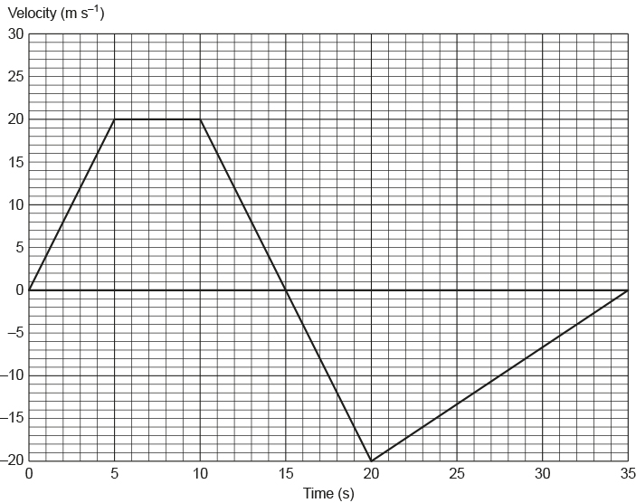

|  |
| --- |
|  |
|  |
|  |
|  |
|  |
|  |
|  |
|  |
|  |
|  |
|  |
|  |
|  |
|  |
|  |
|  |
|  |

Literacy support worksheet

7.3 Acceleration is change in velocity over time

Pages 160–161

Acceleration – speeding up and slowing down

1 Complete the following sentences:

a ‘Acceleration is the rate at which the speed of an object \_\_\_\_\_\_\_\_\_\_\_\_\_\_\_\_\_\_\_\_\_\_.’

b ‘Deceleration is the rate at which the speed\_\_\_\_\_\_\_\_\_\_\_\_\_\_\_\_\_\_\_\_\_\_\_\_\_\_\_\_\_\_\_\_.’

c ‘Gravity acceleration is the increase in speed of an object as it \_\_\_\_\_\_\_\_\_\_\_\_\_\_\_\_\_\_\_\_\_\_\_\_\_\_\_\_.’

2 Imagine a marble rolling along a table.



List two ways that you could:

a change its speed but not its direction.

|  |
| --- |
|  |
|  |

b change its direction but not its speed.

|  |
| --- |
|  |
|  |

3 The graph below shows an object travelling at a constant speed at first. What happens to the object’s speed next?

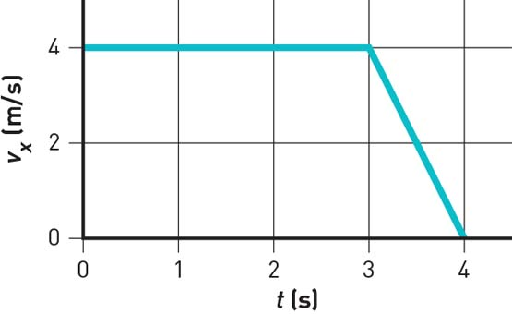

|  |
| --- |
|  |
|  |

4 In the space provided below, draw another speed–time graph that shows an object accelerating quickly before beginning to travel at a constant speed.

|  |
| --- |
|  |

Word detective – Draw and explain

5 Draw a speed–time graph showing a steep gradient and a gentle gradient and explain what each one means. (Hint: Use the information in Figure 7.15 in the student book as a guide.)

|  |
| --- |
|  |

Literacy support worksheet

7.4 An object in motion remains in motion until a force acts on it

Pages 162–163

Newton’s first law: Inertia

1 Use the following word list to fill in the blanks in the paragraph below.

Word list: mass, rest, constant, inertia, unbalanced

Newton’s law of inertia states: An object remains at \_\_\_\_\_\_\_\_\_\_\_\_\_\_\_\_\_\_\_\_\_\_\_\_\_\_\_\_\_\_ or in

\_\_\_\_\_\_\_\_\_\_\_\_\_\_\_\_\_\_\_\_\_\_\_\_\_\_\_\_\_\_\_\_ motion in a straight line unless acted on by a net \_\_\_\_\_\_\_\_\_\_\_\_\_\_\_\_\_\_\_\_\_\_\_\_\_\_\_\_ force. The greater the \_\_\_\_\_\_\_\_\_\_\_\_\_\_\_\_\_\_\_\_\_\_\_\_\_\_ of an object, the larger the \_\_\_\_\_\_\_\_\_\_\_\_\_\_\_\_\_\_\_\_\_\_\_\_\_\_\_\_\_\_.

2 Which of the two shopping trolleys shown in the diagram below has the greatest inertia? Explain your answer.



|  |
| --- |
|  |
|  |
|  |
|  |

3 The diagram below shows a stack of five coloured circular disks made of smooth, polished wood. The plunger is hit quickly and firmly by the hand.

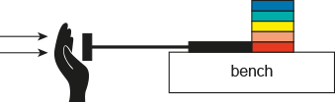

a Fill in the blank in the sentence below.

Due to the law of inertia, objects at rest will stay at rest until \_\_\_\_\_\_\_\_\_\_\_\_\_\_\_\_\_\_\_\_\_\_\_\_\_\_\_\_\_  
\_\_\_\_\_\_\_\_\_\_\_\_\_\_\_\_\_\_\_\_\_\_\_\_\_\_\_\_\_\_\_\_\_\_\_\_\_\_\_\_\_\_\_\_\_\_\_\_\_\_\_\_\_\_\_\_\_\_\_\_\_\_\_\_\_\_\_\_\_\_\_\_\_\_\_\_\_.

b There will be an unbalanced force, due to the plunger, on which coloured disk?

|  |
| --- |
|  |

c Which way will this disk be pushed?

|  |
| --- |
|  |

d What will the other disks do?

|  |
| --- |
|  |
|  |

4 Why might a penguin be able to keep sliding quickly across a flat icy surface? (Hint: Use the law of inertia to explain your answer.)

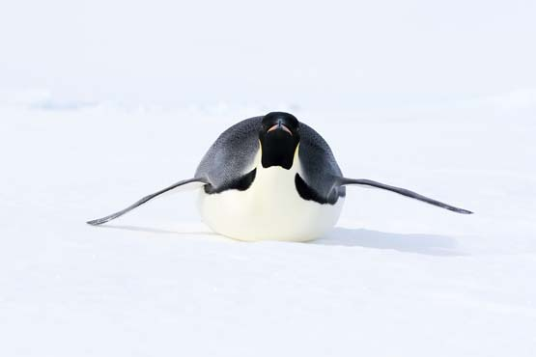

|  |
| --- |
|  |
|  |
|  |

Word detective – Sequencing

5 Michaela took a ride on an amusement park ride called the Space Shot.

The experience included the following, as described by Michaela:

• At the start of the ride at ground level, Michaela said that she felt like she was being pushed very hard downwards into her seat.

• She then felt confused because she knew that she was moving upwards very quickly.

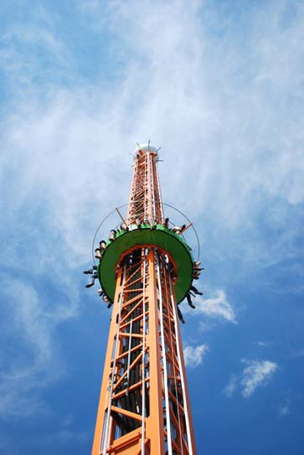

Below is an explanation of what happened to Michaela at the start of the ride. Write a number next to each of the sentences below to put them in the correct order.

Below is an explanation of what happened to Michaela at the start of the ride. Write a number next to each of the sentences below to put them in the correct order.

\_\_\_\_\_\_\_ Michaela will then feel as if she is being pushed very hard back into her seat.

\_\_\_\_\_\_\_ Initially Michaela was at rest on the seat. Due to her inertia, her body ‘wants’ to remain at rest.

\_\_\_\_\_\_\_ According to Newton’s 3rd law of motion, Michaela will push back on her seat with the same amount of force that it is pushing her with.

\_\_\_\_\_\_\_ When the ride starts and the seats accelerate upwards, Michaela’s seat pushes and accelerates her upwards.

Literacy support worksheet

7.5 Force equals mass × acceleration

Pages 164–165

Newton’s second law: *F*net = *m × a*

1 The cyclist in the diagram below is not in a state of constant motion because the forces acting on him are unbalanced.

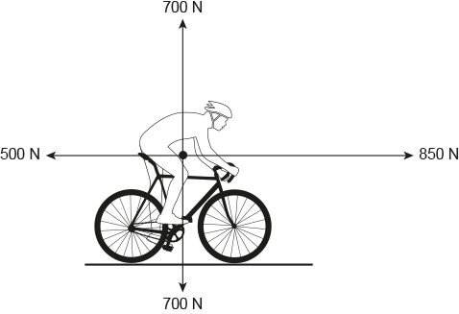

a How is the cyclist in the diagram able to accelerate and move forward?

|  |
| --- |
|  |
|  |
|  |

b In the diagram above, the horizontal force is 350 N. How was this force calculated? (Hint: Use the information in Figure 7.29 and the information on page 165 in the student book to help you.)

|  |
| --- |
|  |
|  |

2 Use the equation below to calculate the force the cyclist will hit the ground with if the mass of the cyclist (*m*) is 85 kg and his acceleration over the top of the bike (*a*) is 5.0 m s–2.

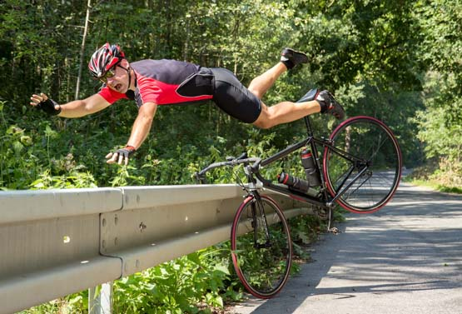

Net force (in Newtons, N) = mass (in kg) × acceleration (in m s–2)

*F*net = *m* × *a*

|  |
| --- |
|  |

3 How much horizontal net force is required to accelerate a 1200 kg car (*m*) at 1.5 m s–2 (*a*)?

Remember: Net force (in Newtons, N) = mass (in kg) × acceleration (in m s–2)

*F*net = *m* × *a*

|  |
| --- |
|  |

Word detective – Draw and label

4 Draw a cyclist and label how different the various forces are acting on him.

|  |
| --- |
|  |

Literacy support worksheet

7.6 Each action has an equal and opposite reaction

Pages 166–167

Newton’s third law: *F*ab = –*F*ba

1 ‘For every action, there is an equal and opposite reaction on the other object.’ What is this statement known as?

|  |
| --- |
|  |

2 Give an example of an action–reaction pair.

|  |
| --- |
|  |
|  |

3 For each of the following situations, describe the action and reaction forces. Remember that each force acts on a different item in the object pair. The first two have been done for you.

|  |  |  |  |
| --- | --- | --- | --- |
|  | Situation | Action | Reaction |
| a | A rocket taking off from its launch pad.  SW0723_01095-r | The action force is the rocket engine pushing out the hot exhaust gases. | The reaction force is the hot exhaust gases pushing the rocket upwards. |
| b | A tennis racquet hitting a tennis ball.  SW0724_01095-r | The action force is the tennis racquet hitting the tennis ball. | The reaction force is the tennis ball pushing back on the tennis racquet. |

|  |  |  |  |
| --- | --- | --- | --- |
| c | A sprinter pushing off from the starting blocks.  SW0725_01095-r |  |  |
| d | A footballer marking a football.  SW0726_01095-rf |  |  |

Word detective – Fill in the blanks

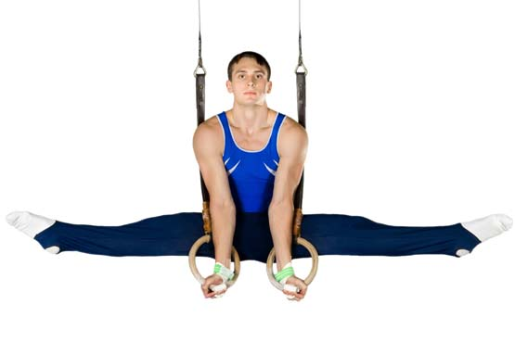

4 Fill in the blanks in the sentences below. The sentences refer to the gymnast pictured above, hanging from a set of rings.

The \_\_\_\_\_\_\_\_\_\_\_\_\_\_\_\_\_\_\_\_\_\_\_\_ force is weight provided by the gravitational force the earth exerts on the gymnast.

The \_\_\_\_\_\_\_\_\_\_\_\_\_\_\_\_\_\_\_\_ force is the gravitational force the gymnast pushes down on the earth.

Literacy support worksheet

7.7 Momentum is conserved in a collision

Pages 168–169

Momentum

1 What is momentum?

|  |
| --- |
|  |
|  |

2 For each of the following three situations, calculate the size of the object’s momentum.

Remember: momentum (*p*) = mass (*m*) × velocity (*v*)

a A speed skater of mass (*m*) of 75 kg moving with a velocity (*v*) of 5.8 m s–1.

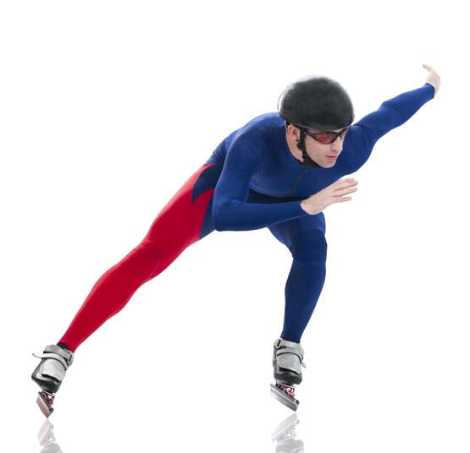

|  |
| --- |
|  |

b A tennis ball of mass (*m*) 58 g travelling at 180 km h–1 (*v*).



To convert grams to kilograms:



To convert kilometres per hour (km h–1) to metres per second (m s–1):



|  |
| --- |
|  |

Word detective – Draw and explain

3 Draw two dodgem cars before a crash and after a crash. (Hint: Use the information in Figure 7.35 in the student book as a guide.)

|  |
| --- |
| Before crash |
| After crash |

4 Summarise how you would calculate each of the following from question 3 above:

a The initial momentum of each car.

|  |
| --- |
|  |
|  |

b The final momentum of one car if it has stopped after the crash.

|  |
| --- |
|  |
|  |

Literacy support worksheet

7.8 Work occurs when an object is moved or rearranged. Energy can be calculated

Pages 170–171

Work, kinetic energy, gravitational potential energy and elastic potential energy

1 Complete the table by identifying which of the following terms belong to each definition:

Word list: work, gravitational potential energy, elastic potential energy, kinetic energy

|  |  |
| --- | --- |
| Term | Definition |
|  | Occurs whenever an object is moved by a force. |
|  | The energy possessed by moving objects. |
|  | The energy possessed by objects raised to a height in a gravitational field. |
|  | The energy possessed by stretched or compressed objects. |

2 What three quantities can this equation triangle be used to calculate?

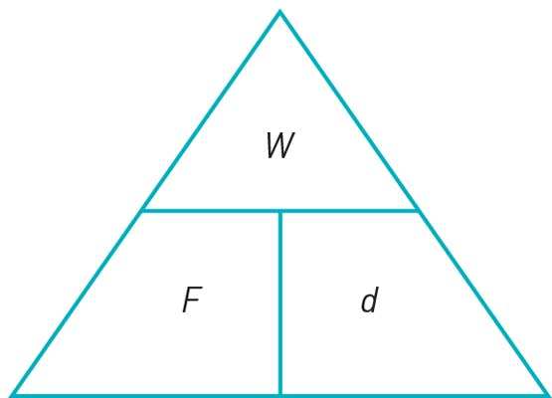

|  |
| --- |
|  |
|  |

3 Write out the equation for the triangle in question 2 in word form.

|  |
| --- |
|  |
|  |

4 If a 48.0 g (*m*) golf ball if is travelling at 150 km h–1 (*v*) and it is 20.0 m (*h*) above the ground, calculate its kinetic energy (KE) by following the steps below.

Use 9.80 m s–2 as the value for gravity (*g*).

To convert units, use 1000 joules (J) = 1 kilojoule (kJ).

a Convert the mass (*m*) of 48 grams to kilograms. (Hint: There are 1000 g in 1 kg.)

|  |
| --- |
|  |

b Convert the velocity (*v*) of 150 km h–1 to metres per second. (Hint: There are 60 seconds in 1 minute, 60 minutes in one hour, and 1000 metres in one kilometre.)

|  |
| --- |
|  |

c Calculate the kinetic energy where:





(Hint: Mass (*m*) is in kg and velocity (*v*) is in m s–2.)

Remember that KE is measured in joules (J), so the final answer will be in joules.

|  |
| --- |
|  |

Word detective – Match the words

5 Match the words with the correct definition.

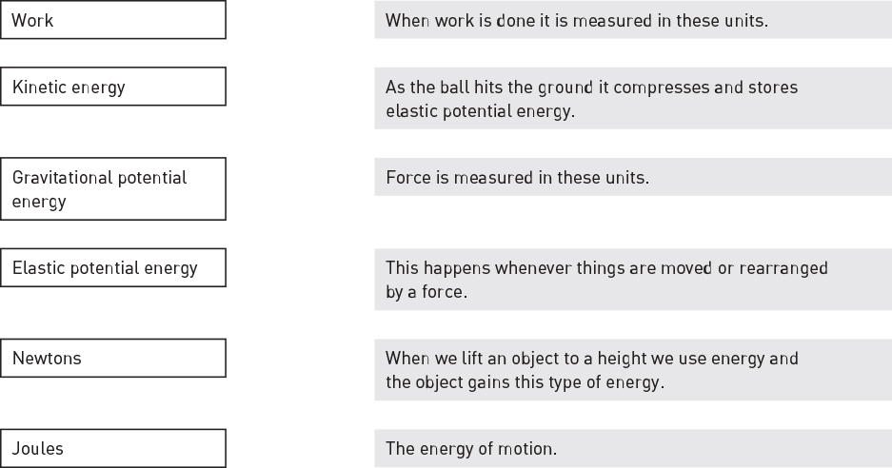

Literacy support worksheet

7.9 Energy is always conserved

Pages 172–173

Conservation of energy

1 What does the law of conservation of energy state?

|  |
| --- |
|  |
|  |

2 A student of a mass (*m*) of 60.0 kg went bungee jumping during her holidays. The bridge from which she jumped was 250 metres (*h*) above a river. She was attached to a bungee cord that had an un-stretched length of 150 metres.

You can assume that the student and the bungee cord are part of an ideal energy conversion system. This means that no energy is ‘lost’ to the environment as heat or sound.

|  |  |  |
| --- | --- | --- |
| SW0739_01095 | SW0740_01095 | SW0741_01095 |
| **A** | **B** | **C** |

**A** Shows the student just before she jumps off the bridge.

**B** Shows the student a short time later when she has fallen a distance equal to the un-stretched length of the bungee cord.

**C** Shows the student when the bungee cord has reached its maximum length and the student is momentarily stationary.

What was the student’s gravitational potential energy (GPE) at point A, on top of the bridge, if ? Hint: *m* = mass in kilograms (kg), *g* = gravity in metres per second squared (m s–2), and *h* = height in metres (m). Use 9.80 m s–2 as the value for gravity (*g*). Remember that GPE is measured in joules (J), so the final answer will be in joules.

|  |
| --- |
|  |

3 What is a pendulum?

|  |
| --- |
|  |
|  |
|  |
|  |

4 Draw an example of pendulum.

|  |
| --- |
|  |

Word detective – Label and explain

5 Label the diagram below to show how a gravitational potential energy (GPE), elastic potential energy (EPE) and kinetic energy (KE) work on a trampoline. (Hint: Use the information in Figure 7.39 and the information on page 172 in the student book to help you.)

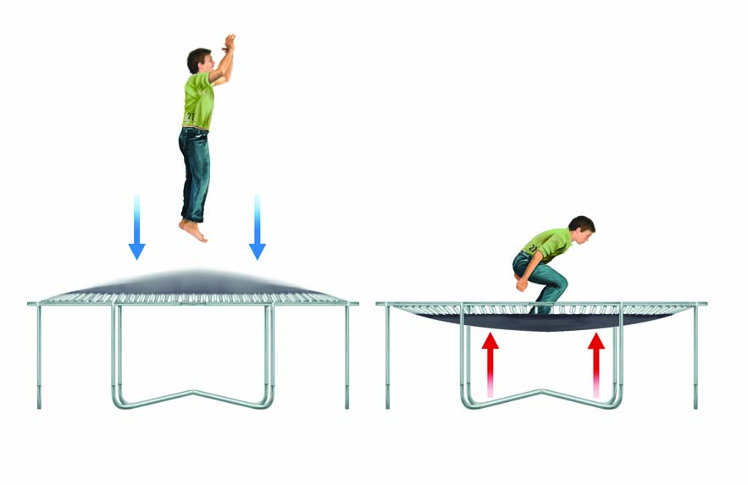

Literacy support worksheet

7.10 Car safety features requires an understanding of Newton’s laws and momentum

Pages 174–175

Newton’s laws and car safety features

1 While out driving in his car, Harry went around a corner too quickly, lost control of his car and ran off the road, colliding with a tree. His friend Ash was beside him in the passenger seat. Both men were wearing seatbelts. The car was travelling at a speed of 54 km hr-1 when it hit the tree.

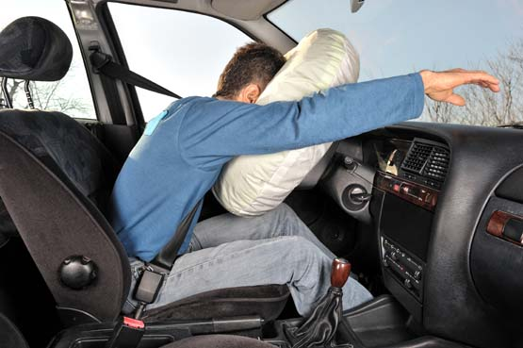

Unfortunately, Ash’s airbag did not work but Harry’s airbag did. Because of this, the time for each of their heads to come to a stop was different.

a What safety features did Harry have in his car?

|  |
| --- |
|  |
|  |

b How does an airbag work?

|  |
| --- |
|  |
|  |
|  |
|  |

2 Describe one other safety feature that might have helped to keep Harry and Ash safe.

|  |
| --- |
|  |
|  |
|  |
|  |

3 Why is it important to have safety features in a car?

|  |
| --- |
|  |
|  |
|  |
|  |

4 The mass of Harry’s head (*m*) is 5.0 kg, the same as Ash’s head.

Harry’s head collided with the airbag and took 0.060 seconds to stop, resulting in an acceleration (*a*)   
of –250 m s–2. (Hint: The acceleration is negative because he is coming to a stop, or decelerating.)

Ash’s head collided with the dashboard and took 0.012 seconds to come to a stop, resulting in an acceleration (*a*) of –1250 m s–2.

Calculate the average force experienced by each of Harry and Ash’s heads during the crash if net force (Fnet) = mass (in kg) × acceleration (in m s–2).



Give your answer to the nearest whole number in Newtons (N).

|  |  |
| --- | --- |
| Harry | Ash |

Word detective – True or false

6 Read the statement and circle whether it is true or false.

a When a car is travelling at 60 km/h the passengers are travelling at 80 km/h. T or F

b The slower a car stops and the smaller the mass, the smaller the force. T or F

c A rigid seatbelt will do less damage than a flexible seatbelt. T or F

d Most young babies are placed in front-facing child restraints. T or F

e Young babies must have back support when travelling in a car. T or F

f An airbag is designed to increase the length of time the driver has to decelerate. T or F

g The crumple zone increases the force experienced by passengers. T or F